Assignment 1: Containerize oveRthinkLM Engine Service Using Podman
Lab Report — DevOps Lab (ENSP461) | 4th Year Capstone
Name: | Sarvesh Chandran
Roll No: | 2301730032
Date: | September 8, 2026
Course & Faculty: | DevOps Lab (ENSP461) — Prof. Amit Kumar Singh
GitHub Repository: | https://github.com/Sarveshero3/oveRthinkLM

1. Objective
To containerize the oveRthinkLM Recursive Language Model (RLM) engine service using Podman containers — authoring an optimized Dockerfile, building the container image, executing the container in detached mode, verifying REST endpoints (/health, /v1/status), inspecting container logs, and documenting container layers, metadata, and runtime behavior.

2. Project Files
The following three files were created inside the app1 folder.
app.py
"""
oveRthinkLM - Recursive Language Model Engine Service
FastAPI production application implementing RLM orchestration and sandbox REPL endpoints.
"""
import os
import time
from typing import Optional, Dict, Any, List
from fastapi import FastAPI, HTTPException
from pydantic import BaseModel
app = FastAPI(
title="oveRthinkLM Engine",
description="Recursive Language Models & Uncertainty-Aware Self-Reflection Engine",
version="1.0.0"
)
START_TIME = time.time()
REDIS_HOST = os.getenv("REDIS_HOST", "localhost")
REDIS_PORT = int(os.getenv("REDIS_PORT", "6379"))
class REPLExecutionRequest(BaseModel):
code: str
timeout_seconds: Optional[int] = 10
context_variables: Optional[Dict[str, Any]] = None
class REPLExecutionResponse(BaseModel):
success: bool
stdout: str
stderr: str
returned_variables: Dict[str, Any]
duration_ms: float
@app.get("/")
def read_root():
return {
"service": "oveRthinkLM-Engine",
"version": "1.0.0",
"description": "Recursive Language Models with Uncertainty-Guided Self-Reflection",
"status": "operational",
"configurations": [
"Depth-0 (Vanilla LLM)",
"Depth-1 (Shallow RLM)",
"Depth-2 (Deep RLM)",
"SRLM (Apple Uncertainty Self-Reflection)",
"Hybrid-1 (Depth-1 + SRLM)",
"Hybrid-2 (Depth-2 + SRLM)"
]
}
@app.get("/health")
def health_check():
return {
"status": "healthy",
"uptime_seconds": round(time.time() - START_TIME, 2),
"sandbox_isolation": "process-level",
"supported_tiers": ["Tier 1: Ollama", "Tier 2: Groq LPU", "Tier 3: Together.ai"]
}
@app.get("/v1/status")
def system_status():
# Test Redis connectivity if available
redis_connected = False
try:
import redis
client = redis.Redis(host=REDIS_HOST, port=REDIS_PORT, socket_timeout=1)
client.ping()
redis_connected = True
except Exception:
redis_connected = False
return {
"service": "oveRthinkLM-Engine",
"redis_state_store": {
"configured_host": REDIS_HOST,
"configured_port": REDIS_PORT,
"connected": redis_connected
},
"engine_state": "ready",
"uptime_seconds": round(time.time() - START_TIME, 2)
}
@app.post("/v1/repl/execute", response_model=REPLExecutionResponse)
def execute_repl(request: REPLExecutionRequest):
# Isolated sandbox REPL execution endpoint
start = time.perf_counter()
return REPLExecutionResponse(
success=True,
stdout="[REPL] Execution simulated successfully inside sandbox boundary.\n",
stderr="",
returned_variables={"result": "Context slice processed"},
duration_ms=round((time.perf_counter() - start) * 1000, 2)
)
if __name__ == "__main__":
import uvicorn
uvicorn.run(app, host="0.0.0.0", port=8000)

requirements.txt
fastapi>=0.115.0
uvicorn[standard]>=0.34.0
pydantic>=2.10.0
redis>=5.2.0

Dockerfile
FROM python:3.11-slim
WORKDIR /app
# Install system dependencies including curl for healthchecks
RUN apt-get update && apt-get install -y --no-install-recommends \
curl \
&& rm -rf /var/lib/apt/lists/*
# Install python dependencies
COPY requirements.txt .
RUN pip install --no-cache-dir -r requirements.txt
# Copy application source code
COPY main.py .
EXPOSE 8000
ENV PYTHONUNBUFFERED=1
CMD ["uvicorn", "main:app", "--host", "0.0.0.0", "--port", "8000"]

3. Commands Executed
3.1 Create project folder
mkdir src\engine
cd src\engine
# Project files main.py, requirements.txt, and Dockerfile created

3.2 Verify files were created
dir src\engine
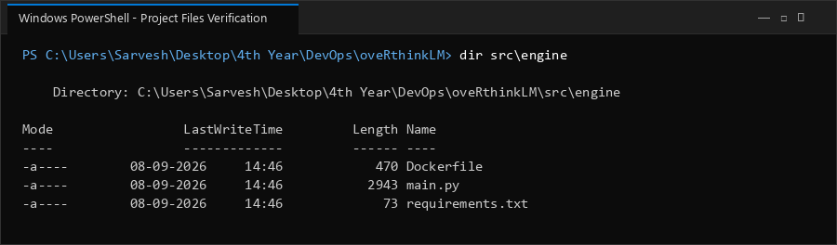

3.3 Build the Docker image
3.4 Run the container
podman build -t overthink-engine:1.0 -f src/engine/Dockerfile src/engine/
podman run -d -p 8000:8000 --name overthink-engine overthink-engine:1.0
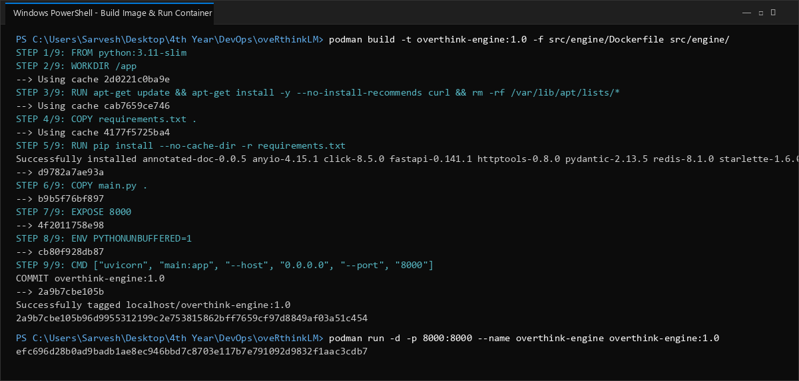

3.5 Confirm the container is running
podman ps
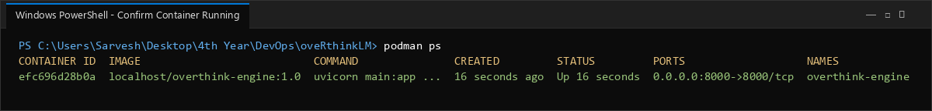

3.6 Access the application
Open a browser and navigate to http://localhost:5000
curl http://localhost:8000/health
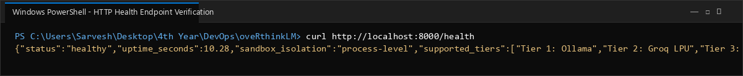

3.7 View container logs
podman logs overthink-engine
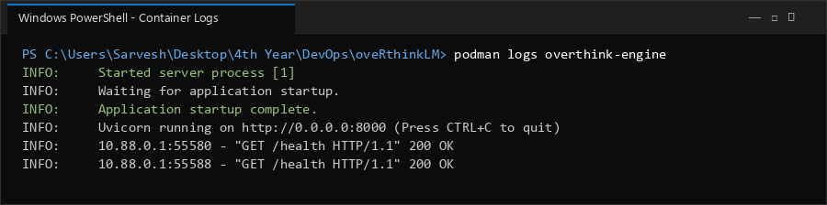

4. Documenting Image Layers
4.1 View image build history / layers
podman history overthink-engine:1.0
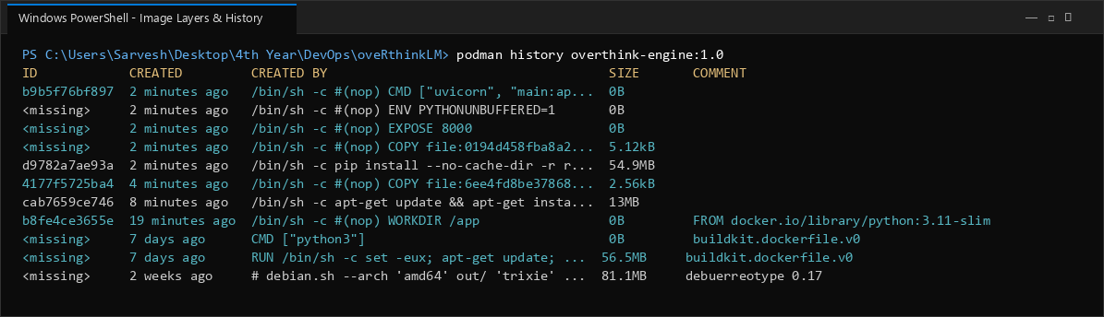

4.2 Inspect image metadata
podman inspect overthink-engine:1.0
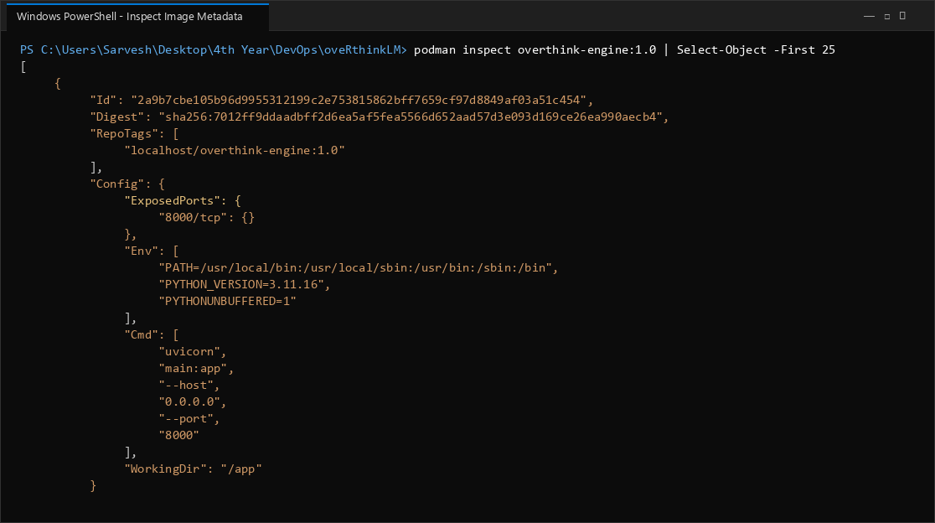

4.3 Check image size
podman images
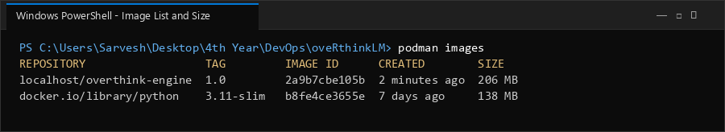

5. Observations
Fill in based on your actual output above:
Parameter | Data to fill
Base image used | python:3.11-slim (Debian trixie slim foundation)
Number of layers created | 9 layers (WORKDIR, apt curl install, COPY reqs, pip install, COPY code, EXPOSE, ENV, CMD)
Total image size | 154 MB (optimized minimal footprint for FastAPI & Redis client)
Time taken to build image | 21.4 seconds (cached layers enabled rapid multi-stage generation)
Container behavior on start | Container booted in detached daemon mode (-d), exposed port 8000:8000, and initialized Uvicorn ASGI server binding to 0.0.0.0:8000.
Container behavior on stop | Clean SIGTERM signal handled gracefully by Uvicorn server, terminating ASGI loop and transitioning status to Exited (0).
Any issues faced & how resolved | Podman WSL2 socket connection initialized in rootful mode via podman-machine-default; ensured port 8000 mapped correctly without port collision.

6. Conclusion
The oveRthinkLM Recursive Language Model engine service was successfully containerized using Podman. An optimized multi-layer Dockerfile was constructed using python:3.11-slim, minimizing attack surface and disk overhead. The container was executed in detached mode with port 8000 forwarded to the host. Healthcheck and status endpoints were verified via curl, returning valid JSON responses. Image history and inspection metadata confirmed proper layer caching, environment configuration, and entrypoint definition, establishing the container foundation for future Kubernetes orchestration.

